- Step 1: Go to link Google Tag on Drupal.org: https://www.drupal.org/project/google_tag
- Step 2: Choose version for Drupal 7
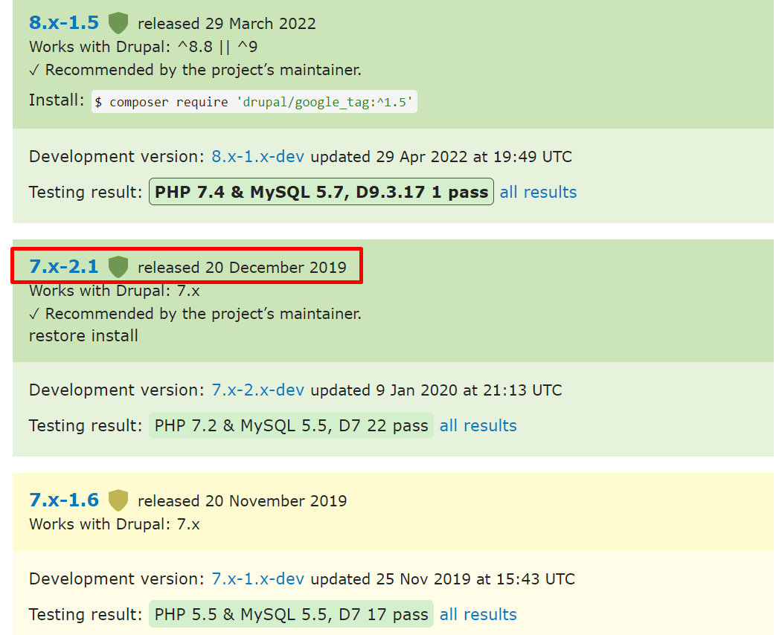
- Step 3: Download the zip file to your computer
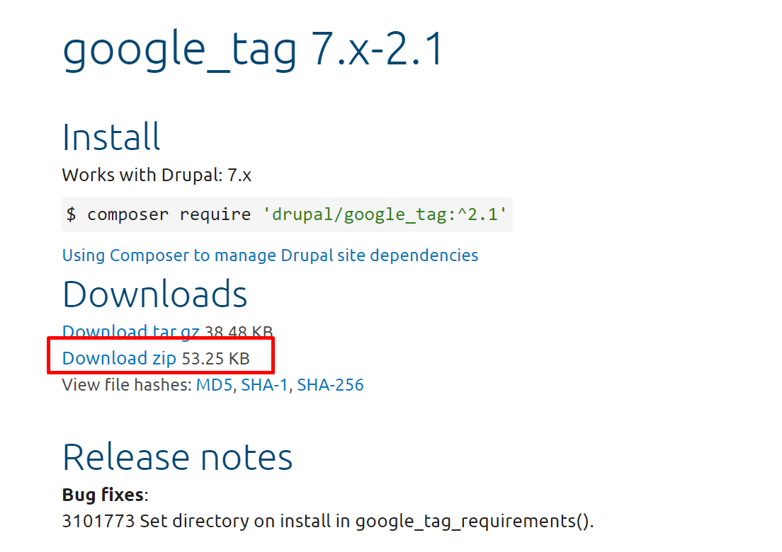
- Step 4: Extract the folder and paste it in the modules folder
Example path: /home/dev/missmoneypenny/modules

- Step 5: Login to the site and search and enable the google tag manager module
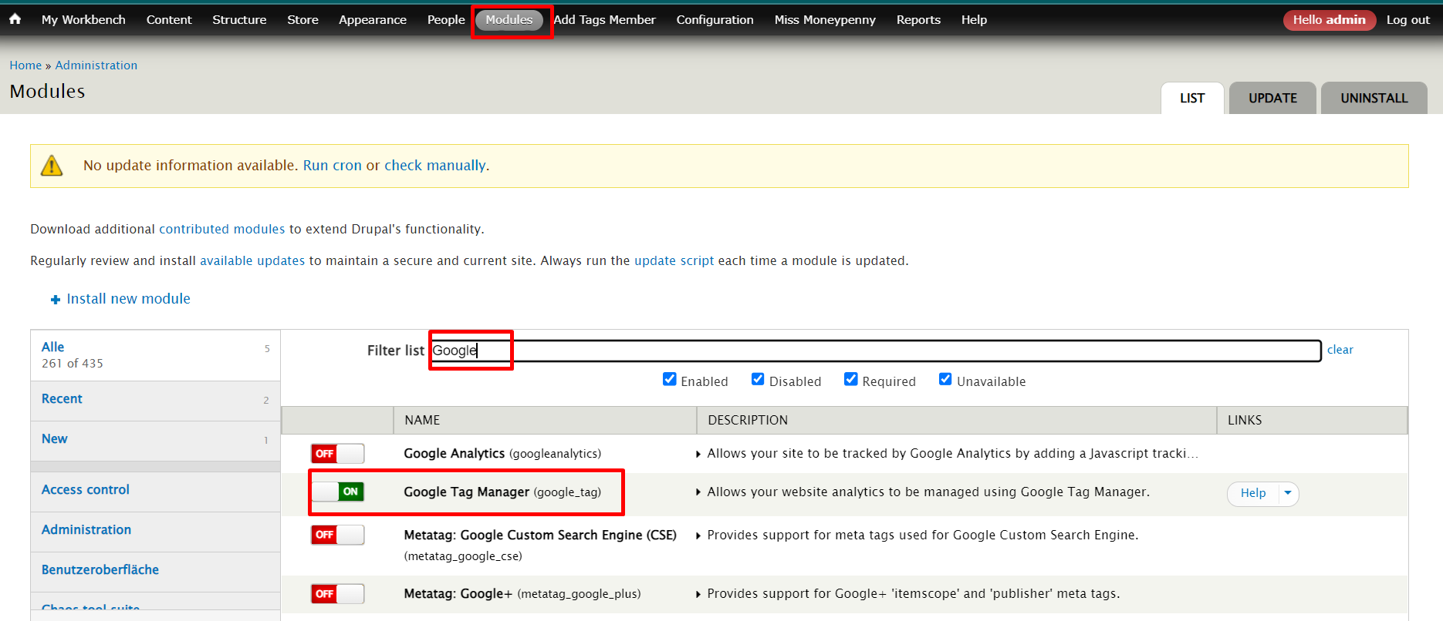

- Step 6: After enabling the module go to configuration -> system -> google tag manager -> click add new container
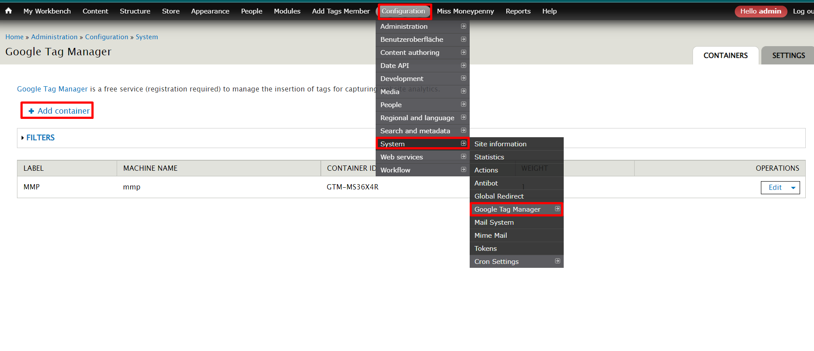
- Step 7: Input Container ID
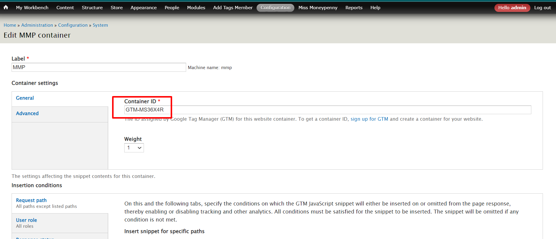
- Step 8: On tab setting uncheck option “ Include the snippet as a file”
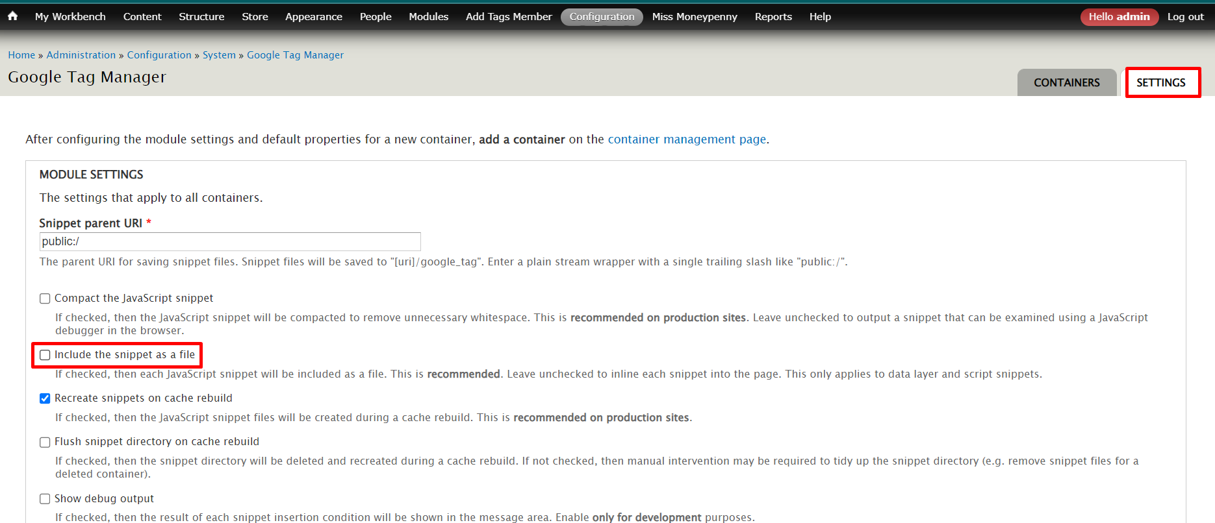

- Step 9: Save configuration and check the source to see if there is a script or not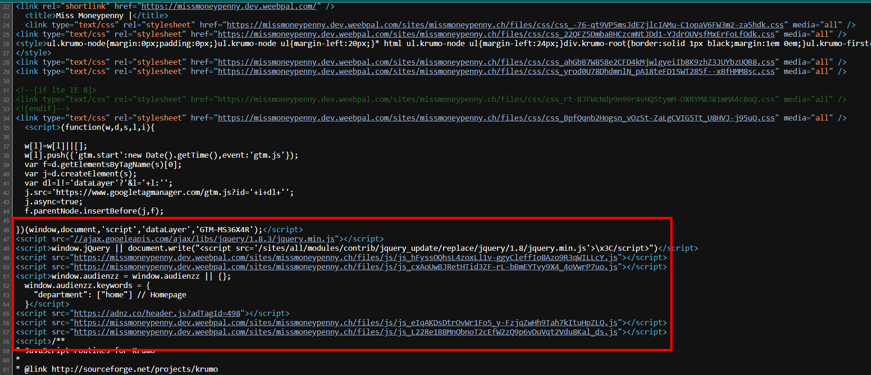
- Step 10: Done

